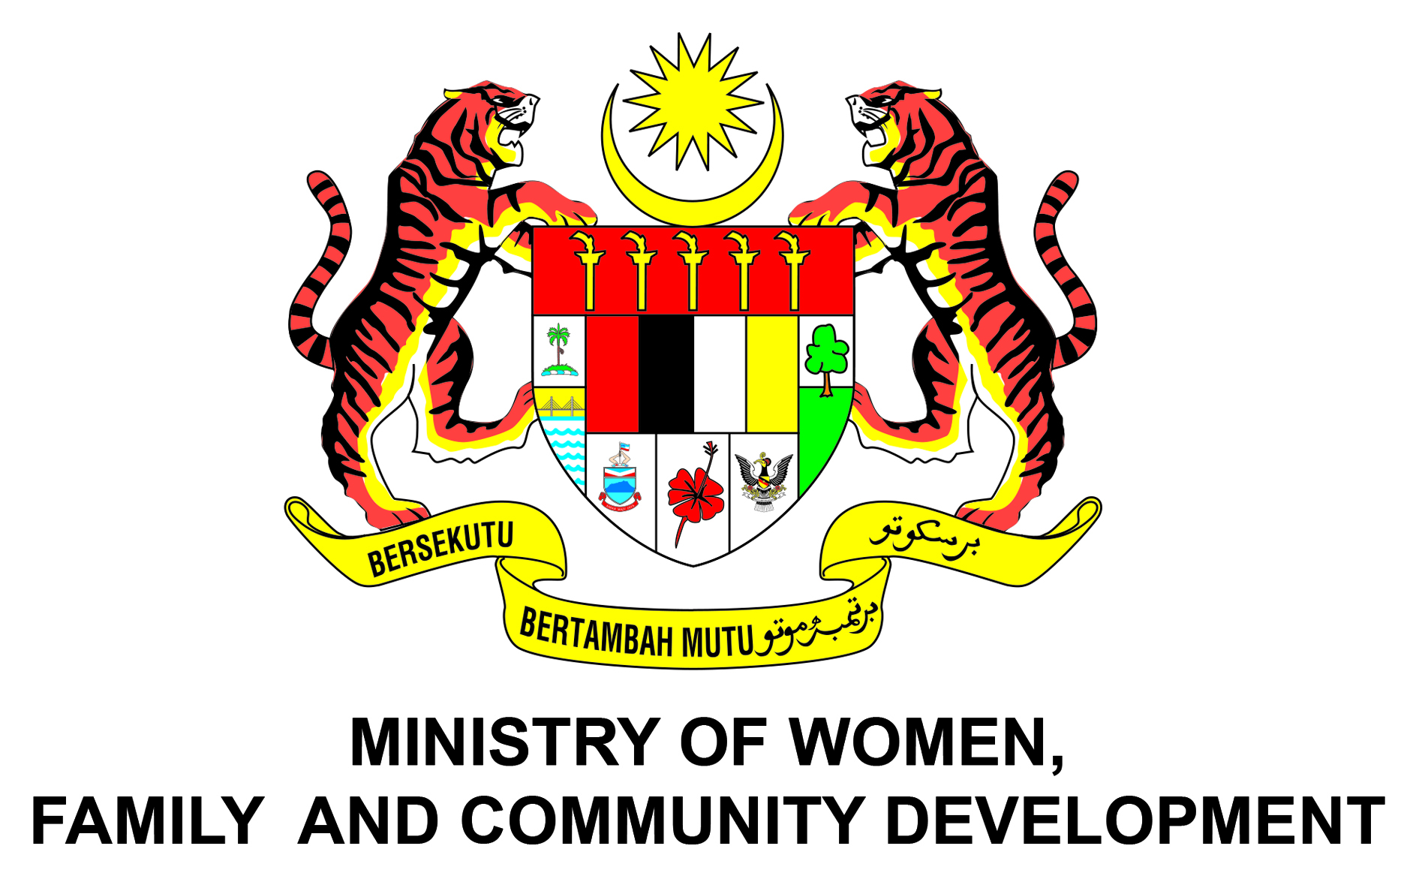

PRESS RELEASE

SENIOR OFFICIALS’ MEETING FOR ASIA PACIFIC REGIONAL FORUM OF MANAGEMENT OF SOCIAL TRANSFORMATIONS (MOST)
KUALA LUMPUR, 20 MARCH – The Senior Officials’ Meeting For Asia Pacific Regional Forum of Management of Social Transformations (MOST) begins today at The Sunway Putra Hotel, Kuala Lumpur officiated by YBhg. Datuk Dr. Rose Lena binti Lazemi, Secretary General of the Ministry of Women, Family and Community Development. The two days meeting is the first time in the history of MOST is being held in the Asia-Pacific region.
The objective of this forum is to share our knowledge on social transformation and experience in developing, implementing innovative and effective public policies based on real situation on the ground in our respective countries. This forum will also serve as an opportunity for participating countries to showcase their success stories in implementing social transformation programmes.
With the theme “Building Inclusive Societies”, the topics that will be discussed in this forum are in line with the United Nations Sustainable Development Goals or SDGs which set ambitious targets for more inclusive and equal growth, and to end hunger and poverty by the year 2030. Three sub-themes have been proposed in the efforts to build inclusive societies namely Ageing, Empowerment of Women and Social Innovation.
During her opening remarks, Datuk Dr. Rose Lena said that “Malaysia will be an aged nation by 2030 where about 5.8 million (15%) of the population will be aged 60 and above. Thus, the National Policy and Plan of Actions for Older Persons 2011 is looking into the potential of the elderly so that they remain active and productive in national development”.
In addition, she also mentioned that the participation rate of women in the labor force has increased from 5.5 million in 2015 and rose to 5.6 million in the 3rd quarter of 2016. The Government of Malaysia has set forth a plan to increase women’s participation in the labor force to 59 percent by the year 2020.
On social innovation, the Ministry of Women, Family and Development has been actively involved on promoting social innovation through Social Welfare Department as highlighted in the Eleventh Malaysia Plan.
The meeting was attended by 150 international delegates, senior officers from various ministries and agencies, corporate sectors and Non-Governmental Organizations (NGO). Among topic that have been discussed were overview of regional research on building inclusive societies, sharing on national experiences on building inclusive societies and presentation on MOST schools.

Corporate Communications Unit
Ministry of Women, Family and Community Development
20 March 2017

Footnote : MOST is a program under the Commission of Social Sciences, UNESCO aims at designing, coordinating and implementing UNESCO programs and activities related to social sciences, inclusivity and gender equality. MOST was launched with a view to strengthen the dissemination of knowledge to the member states by encouraging evidence-informed approaches through a sustained dialogue between researchers and policymakers.

